Wireshark doo dooo do doo...

(picoCTF 2021)

Looked at packets from specific protocols first, starting with HTTP:

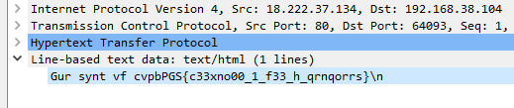Most back and forths were POST requests from the IP address 192.168.38.104 to 192.168.38.103, which all resulted in 200 OK replies but there was one GET request from 192.168.38.104 to 18.222.37.134 who’s reply seemed to include an encrypted version of the flag:

By knowing that the flags are in the format of picoCTF{}, we can tell that the cypher used was ROT13 thus giving us the flag after decoding.